FAIR HAVEN
TOWN PLAN
**2024 DRAFT **
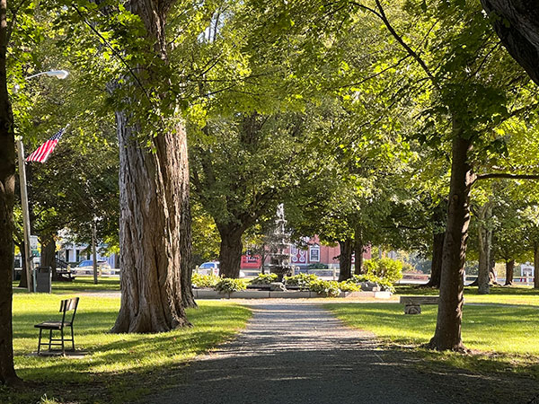

Adopted by the Fair Haven Selectboard:
_______________________

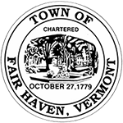
Fair Haven
Planning Commission
- Bob Richards (Chair)
- Cindy Pritchard
- Patrick Frazier
- Lorraine Brown
- Jason Coupal
Fair Haven
Selectboard
- Bob Richards (Chair)
Thank you to all who helped!
- Glen Traverse (Board Clerk)
- Jason Coupal
- Rich Greenough
- Chadd Viger

Town Manager – Joe Gunter
Zoning Administrator – Phil Adams

Technical Assistance from:

Logan Solomon – Planner

TABLE OF CONTENTS
Contents
INTRODUCTION 4
HISTORY AND CULTURE 6
FACILITIES AND UTILITIES 12
ECONOMIC DEVELOPMENT 23
HOUSING 27
TRANSPORTATION 31
NATURAL, SCENIC, CULTURAL, AND HISTORIC RESOURCES 34
ENERGY 38
FLOOD RESILIENCE 41
LAND USE 44
IMPLEMENTATION & AJACENT MUNICIPALITIES 47

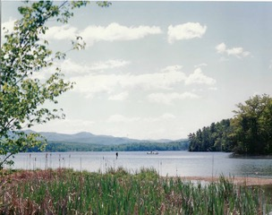
The Old Marsh Pond or Eagle Lake

INTRODUCTION

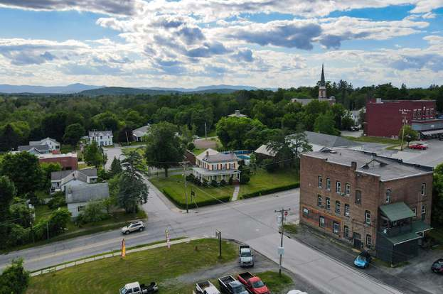
The proud Town of Fair Haven, “Town,” is along the Vermont-New York border and is at the intersection of Route 22A and Route 4. The Town is in a great location, being 25 minutes from Rutland and about 1.5 hours away from Burlington VT, Hanover NH, and the greater Albany NY area.

Fair Haven is 17.2 square miles in size, full of friendly people, scenic beauty, and businesses and services to meet your needs. With a vibrant business district, Victorian architecture, and a downtown park full of sugar maples, Fair Haven is a charming Town to call home and visit. Fair Haven was chartered in 1779, grew with the rise of the slate industry, and slowly evolved into the Town we know and love today.
Figure 1: Drone photography of the Town of Fair Haven

Purpose
The purpose of the Fair Haven Town Plan, “The Plan,” is to serve as a long-term guide for the future health and well-being of the community. Town Plans are updated and readopted every eight years per the Vermont Planning and Development Act (24 V.S.A. §4387a). The Plan is the initial component of an ongoing process, establishing a framework of planning recommendations to ensure that decisions made at the local, regional, and state levels align with the Town’s objectives for providing a clear and positive direction for future development.
These objectives are listed as “Goals” in the box below and at the end of each respective chapter, alongside a set of actions. It is the intent of the Planning Commission, and the Town as a whole, to execute the listed actions over the next eight years and beyond.
To guide future growth and development of land, and public services, and to protect the environment, the Plan identifies the following goals:
- To plan for, finance, and provide an efficient system of public facilities and services to meet current and future needs.
- To broaden access to educational and vocational training opportunities sufficient to ensure the full realization of the abilities of Fair Haven’s residents.
- To encourage the availability of safe and affordable childcare.
- To maintain and enhance recreational opportunities for Fair Haven’s residents and visitors, and to preserve Fair Haven’s New England character.
- To provide a strong and diverse economy that provides satisfying and rewarding job opportunities and to expand economic opportunities.
- Ensure and support the availability of safe and affordable housing for all residents and the efficient use of land.
- Encourage a welcoming community where individuals and families from diverse backgrounds want to live in Fair Haven and are valued and respected.
- To provide safe, convenient, economical, and energy-efficient transportation systems that respect the integrity of the natural environment, including public transit options and paths for pedestrians and bicyclers.
- To identify, protect, preserve, and showcase important natural, scenic, cultural, and historic features and areas of Fair Haven’s landscape.
- To maintain and improve the quality of air, water, wildlife, and forests.
- To support local agriculture, forestry, and related industries.
- To provide for the wise and efficient use of Fair Haven’s slate and geologic resources.
- To make efficient use of energy, reduce emissions of greenhouse gases, and find a balance between the use of fossil fuels and renewable resources.
- To support flood resiliency and ensure the Town of Fair Haven can recover from flood events quickly.
- To plan development to maintain the historic settlement pattern of compact villages separated by rural countryside.

HISTORY AND CULTURE
Early History
Vermont was formed out of conflict between New York and New Hampshire and Fair Haven was at the heart of that conflict. Due to being on the New York State border, Fair Haven was not incorporated under the New Hampshire grants unlike most of Vermont. Instead, on October 27, 1779, Capt. Ebenezer Allen and 76 of his associates were granted “a tract of unappropriated lands within the state for settling a new plantation to be erected into a township.”
Nearly 13 years later, on April 26, 1792, by an act of the Vermont General Assembly, the town of Fair Haven was divided into West Haven and Fair Haven along the present boundary line. While West Haven obtained the larger land mass, rich in agricultural soil, and access to Lake Champlain, Fair Haven was blessed with good waterpower, with falls on the Castleton River, thus becoming a prominent mill town in Central Vermont.
By the late 1700’s the town included a sawmill, ironworks, paper mill, tannery, cabinet maker’s shop, cloth dress works, hat shop, distilleries, and inns. Many of these industries were started by the visionary Matthew Lyon. Lyon, a member of the Green Mountain Boys, arrived in Fair Haven in 1782. Active politically, Lyon was elected to the U.S. Congress and re-elected while in prison in Vergennes for publishing insults against President John Adams. Although he was found guilty by President Adams’ supporters in court in Rutland, Lyon continued to fight for Americans’ right to freedom of speech even from his jail cell.
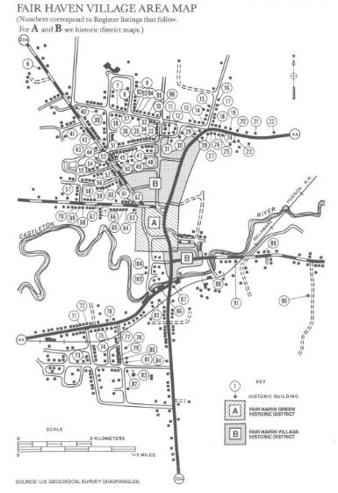
Historic Buildings
In 1988, the Vermont Division for Historic Preservation published The Historic Architecture of Rutland County, detailing the historic buildings in Fair Haven, including over 100 architecturally and historically significant buildings. Although most of these buildings are residential, historic churches, barns, and civic buildings can be found in Town. Some of these buildings are in the Fair Haven Green Historic District, which encompasses the historic business district of Fair Haven. In 1980, the Fair Haven Park and the buildings surrounding it were listed on the National Register of Historic Places.
The north end of the Park is anchored by the Municipal Building. In keeping with the architectural style that appeared to dominate most of the prominent buildings around the park, the school adopted the then popular Italianate architectural style. Built in 1861, the building housed the Fair Haven school until 1916 and the High School until 1957. The offices of the Town Clerk, Town Manager, the Police and Fire Departments, as well as the Historical Society are housed there. The first major renovation of the structure in more than a century and a half was begun in 2022, including the addition of an elevator which allows easy access to the second floor. When renovations are complete, the large auditorium on the second floor will provide much needed space for community gatherings.
Figure 2: Downtown Historic Buildings - The Historic Architecture of Rutland County, 1988
The Fair Haven Grade School and the Fair Haven Free Library anchor the east side of the Park. The Grade School, built in 1916, serves Early Education through grade 6. The building has undergone several additions to add gymnasium and classroom space, handicapped access, and energy upgrades. Behind the Colonial Revival-style façade, the Grade School maintains state-of-the-art educational resources for Fair Haven’s youth.
To the south of the Grade School sits the Fair Haven Free Library. A library existed in Fair Haven as early as 1826, but it was not until 1904 when steel magnate Andrew Carnegie offered $8000 that the current structure was erected. One of only four Carnegie libraries in Vermont, the Fair Haven Free Library is home to a large collection and offers up-to-date digital service. The Friends of the Library host a myriad of community programs throughout the year.
The three churches around the park are the core of community life for many Fair Haven residents. The First Congregational Church sits at the corner of Caernarvon Street and North Park Place. Formed in 1803, the present wooden structure was built in 1812. At the opposite end of the Park sits the First Baptist Church, organized in 1867. Built between 1870 and 1873, this is a fine example of Romanesque architecture. The United Methodist Church anchors the northwest corner of the Park. A Methodist congregation was organized in Fair Haven in 1825 and built its first church in 1843. That wooden structure burned in 1877 and was replaced by the current brick building in 1878. In 1856 the first Catholic Church was erected on the northeast corner of the town green. It was replaced in 1874 by the Gothic style building still in use today on Washington Street. The largest of Fair Haven’s churches, Our Lady of Seven Dolors, also known as St. Mary’s Church, is the only one with a private cemetery, located a few blocks north of the church. Other churches in Fair Haven include St. Luke’s Episcopal Mission on North Main Street and the Revive Church on Route 22A on the south side of Fair Haven.
Two of the most impressive structures in the Historic District are the Adams House and the Marble Mansion Inn. The Adams House located on the corner of West Park Place and Adams Street, was built in 1860 in the High Italianate style using marble from the mill owned by Joseph Adams and Ira Allen. It is currently owned and operated by the Housing Trust of Rutland County and is subdivided into apartments for the elderly and people with disabilities. The Marble Mansion Inn, on West Park Place, was constructed of Danby marble in 1867 for Ira C. Allen. Originally a one-family home, it is now a bed & breakfast. It was built in the Italianate/Second Empire style and contains a number of marble fireplaces.
The Fair Haven Green Historic District also contains an array of impressive family homes. Among them are the Sutliff House (next to the Library) built in 1835, the Allen House (at the south end of the Park) built in 1885, the Mallory House (next to the Baptist Church) built in 1829, and the Cutler-Allen house (on West Park Place) built in 1810. There are also many commercial buildings included on the National Register which remain largely untouched and retain their original architectural integrity. The Community Bank currently occupies the Italianate building on the east side of the Park next to the Library. It was originally built as a bank in 1870. The Green Block (circa 1869), the Calvi Block (circa 1888), and the Culver Block (circa 1895) are examples of buildings which, although altered some over the years, have retained their architectural charm. The Culver Block, which currently houses a laundromat on the ground floor, has a large auditorium with a stage and balcony on the third floor which at one time served as the Opera House.
Surrounding the park, a fence of marble posts and wood rails was installed in 1853. One hundred fifty-five years later, few marble posts remained intact. To replace the broken and decaying posts, the Fair Haven Historical Society conducted a large-scale fund-raising campaign to pay for specially cut replacement marble posts in keeping with the historic district. The fountain in the middle of the Park also reflects the historic nature of the park. The original fountain was installed in 1911. The Fair Haven Rotary Club replaced the first one with a slate fountain in 1976, and the present ornate iron fountain in 2008. The Fair Haven Police Department provides security for all major gatherings in the park and other locations in town.
Economic History
Fair Haven’s Alonson Alan and Caleb Ranney began Vermont’s first slate quarry at Scotch Hill in 1839. Slate became the basis of the most prominent and lucrative business in town, supported by the immigrants from Wales and Ireland who not only provided labor but experience and expertise.
The slate industry dominated the economy of the Slate Valley for the next several decades. In 1907, a strike by slate workers took a heavy toll on the industry, and the stock market crash in 1929 further impeded the business. Demand for slate dwindled while other industries were introduced and continued to be successful. Two well-known businesses in Fair Haven were the Clock Company started in 1896, and the United Shirt and Collar Company in the early 1900s.
A major attraction of the town was the Fairmont Trotting Park, constructed in 1874 south of the village near the current Route 4. The trotting park was the site of a successful annual fair from 1883-1916. As many as 17,000 people attended the Fair Haven fair on a single day. After World War I, when the land was no longer used as a trotting park, the track was used to race automobiles. It became another great success as the Fairmont Speedway in the early 1960s and, after a few years, moved to a location in West Haven.
From the time of the first newspaper published by Matthew Lyon and one of his sons in 1790, to the last publication of the Promoter in 1990, Fair Haven was a center for news in the Slate Valley. Several well-known newspapers and periodicals were printed in town, including the Vermont Journal and the Fair Haven Era. Both have been out of publication for decades.

Among the many advancements of progress in Fair Haven was its airport, the only municipal airport in Vermont besides Burlington International. In 1934, the Town of Fair Haven purchased 145 acres of land for use as an airport. By 1937 Merrick Counsell was offering flying lessons and scenic rides. Many of Counsell’s students went on to have distinguished military careers, and, in World War II, the Fair Haven Municipal Airport was used to train Army pilots and civilian plane spotters. Over the years numerous facilities were added to the airport, including an equipment maintenance facility constructed by the Vermont National Guard which remains in operation today. In 2004, plans for commercial development received approval from the State of Vermont and the Federal Aviation Administration but the project failed to obtain approval of the Selectboard and the airport was officially decommissioned. The airport site now is used by model airplane flyers and as a dog park.

Culture
Fair Haven is rich in civic organizations. Many of these organizations utilize the park and the downtown area for colorful and consistently popular annual events. A good example is the Itty Bitty Committee (IBC), which is dedicated to beautification projects downtown and events in the park that bring the community together. On the first of each year, they design, create, and begin distribution of the town welcome package for new arrivals with a list of upcoming annual events, organizations, important telephone numbers, and more. These are free to all newcomers.
The park has long been the social center for events. Among them are the Farmers Market, Concerts, Touch a Truck, and Santa arriving on the fire truck, and more. Every Thursday, through all kinds of weather, there is a commemorative service in the Veterans Memorial Day Park to honor our members of the military who remain Missing In Action. This is the oldest remembrance event in the United States.

There are many active civic organizations in Fair Haven that welcome volunteers to carry out their programs and events including:
- The Art Club
- Catholic Daughters
- Cemetery Committee
- American Legion Post 49 and Auxiliary
- Fraternal Order of the Eagles Aeries 2784
- Masons Eureka Lodge #75 and Auxiliary
- Fair Haven Fire Department
- Slate Valley Community Action Center

Important Fair Haven Sites
- Diverse Architecture of the houses, churches, and downtown buildings.
- Fair Haven Airport Park: hiking, visiting the Dog park, and the RC Flyers (motorized model planes).
- Veterans Memorial on the east side of the park. Thursdays memorial gathering for POWs.
- Civil War Cannon on the North end of the park.
- The Historic Downtown.
- The Welcome Center on the border of Vermont and New York.
- Three murals: corner of Main and River Street; the corner of Main St. and Liberty St., and in the corner of the Main Street by the Tavern

Demographics
In 2020, 2736 people lived in Fair Haven. Figure 3 shows Fair Haven’s population change over the decades. The population has fluctuated but is roughly the same as in the early 1900s.

Figure 3: Town of Fair Haven Population (1790-2020)- 2020 U.S. Decennial Census
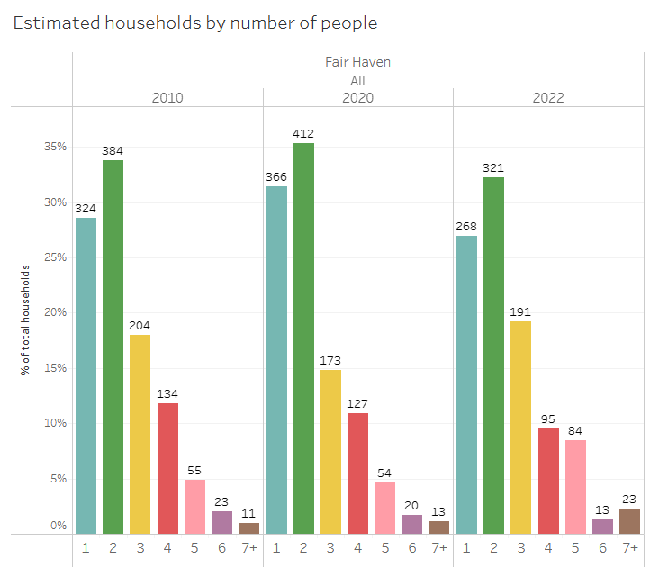
Fair Haven had 1,165 households and an average household size of 2.75 people in 2020. Figure 4 shows most households have 1 or 2 people. The average household size in Town has grown since 2010, unlike Rutland County, the state, and the entire country.
Figure 4: Household Size - 2010 and 2020 Decimal Census, 2022 American Community Survey 5-Year Estimates
Figure 2: Households by number of people – U.S. Census Bureau (2010 and 2022 U.S. Decennial Census, 2022 5-Year American Community Survey Estimate)
The median age of Fair Haven’s residents is 42.2 years old making the Town the second youngest by age in Rutland County. Nearly half of the Town’s residents are under 40 and 22% of the Town’s population is under 18.
More than 1 out of every 4 residents have lived in Fair Haven since 1999.
Figure 5: Fair Haven 2020 Population by Age - 2020 U.S. Decennial Census
HISTORY and CULTURE GOALS
- To identify, protect, preserve, and showcase important natural, scenic, cultural, and historic features and areas of Fair Haven’s landscape.

HISTORIY and CULTURE ACTIONS
- Generate a Town open space, significant features, recreation/open space, and natural resources plan and work with the RRPC to acquire grants funds to lower the cost of creating and implementing the plan.
- Continue to support Concerts in the Park, Spring Fling, Apple Fest, and other cultural events that promote Fair Haven and its viability as a sub-regional cultural hub to the greater Rutland County and eastern Washington County, New York regions.
- Support the owner of the Opera House to help realize and reopen the venue for additional value-added cultural opportunity.
- Promote cultural events by local and regional chambers of commerce, and the Fair Haven Historical Society in and around Fair Haven, especially related to cultural events.
- Research and implement ways that ensure the preservation of Fair Haven’s historic architecture and history.
- Apply for historic grants (e.g., Historic Preservation of Vermont and the Vermont Community Development Program) to carry out Town-identified projects of historic consequence.
- Create a Historic Preservation Board
- Work with the Fair Haven Historical Society to do interactive presentations on Fair Haven’s history. These presentation shall be for a variety of audiences, including for school-aged children.
- Identify and designate a site for a museum that honors Fair Haven’s history.
- Ensure the integrity of the Green by forming a town committee and by annually allocating money to this effort.
- Review and update Historic Properties currently listed on the State and National Registers of Historical Places
- Review permits that pertain to Historic properties to ensure the historical integrity of the town is maintained.
- Create a binder containing the full history of the town of Fair Haven that will be available for the people.

FACILITIES AND UTILITIES
The Plan supports growth that does not exceed the ability of the Town to provide facilities and services, including but not limited to the ones listed below and does not conflict with the Plan.
Municipal Water System
The town’s urban compact and a few areas outside it (most notably properties adjacent to the water main between the E. Whitcomb Hyde Water Treatment Plant and the urban compact) are served by a municipal water system. The system was originally constructed in the early 1880s with many extensions, upgrades, and rehabilitations since then. The state-of-the-art water treatment plant was built adjacent to Inman Pond, our principal water source, and went online in December 1982.
Inman Pond is an eighty-acre pond fed by springs, run-off, and a small, unnamed stream that drains from marshy ground to the south. The Inman Pond watershed, free of development, is fully owned by the Town to keep it a pristine water source. Inman Pond has a storage capacity of 450 million gallons. On February 16, 2017, a Permit to Operate was issued by the State of Vermont and contains an engineer’s estimated yield for Inman Pond at 400 gallons per minute (gpm).
Two additional water sources north of Inman Pond, the Howard and Sheldon Reservoirs, were created in 1907 by building concrete dams with wheel-operated sluice gates. Pipelines were constructed at the same time to bring spring run-off down to Inman Pond to supply additional water. The Howard Reservoir was last used for this purpose in 1982, and the reservoir was emptied about 5 years later. The Sheldon Reservoir, abandoned as a secondary water source in 2009, remains an approved water source. The current Temporary Permit lists the yield of the Sheldon Reservoir as “unknown”.
With Inman Pond now constituting the single source of the town’s water supply, the State of Vermont has encouraged the Town to develop a plan and identify one or more alternatives as emergency sources if Inman Pond is compromised. The Plan encourages the Town to scope the feasibility of using Howard and Sheldon Reservoirs, or other waterbodies, as a potential emergency source.
The E. Whitcomb Hyde Water Treatment Plant uses pulsated up-flow clarifiers and rapid sand filters plus chemicals for flocculation, pH adjustment and disinfection. Originally designed to treat 750,000 gallons per day (gpd), changes, such as using greater depths of sand in the filters, have reduced the capacity to 560,000 gpd according to its current Permit.
A 500,000 gallon finished water storage tank at the water treatment plant and another 500,000 gallon water storage tank off South Main Street provide pressurized water for domestic use and fire protection through 890 service connections and roughly 86 fire hydrants. Water flows by gravity through the entire system.
For 2022 and 2023, production data show an Average Daily Demand (ADD) of 147,973 gpd with similar numbers in 2012 and 2023. The 2017 Permit to Operate gives the Maximum Day Demand of 576,000 gpd and a maximum day demand of 400 gallons per minute (gpm).
A study prior to the 2017 Permit to Operate has shown that approximately 23% of the water produced at the water treatment plant is unaccounted for by meters at the water service connections due to meter inaccuracies, hydrant flows and leaks. In 2019, the Water Department initiated a townwide meter replacement. Now, with new more accurate meters, leak repairs, and replacing some fire hydrants, the distribution system shows a significant reduction in water production thereby reducing the cost of producing water through less water and chemicals used.
The distribution system contains an amalgamation of pipe materials, sizes, and ages. Copper pipe, galvanized, cast, and ductile iron pipe as well as cement water mains, ranging in size (from 4” to 12” in diameter) and age (from brand new to 135 years old), can be found throughout the system. Many water lines have been replaced, especially since about 1980. The condition and age of water valves throughout the system mimic that of the water mains. The fire hydrants themselves are in better overall repair. The Water and Fire Departments collaborate on maintaining flow data on hydrants and use a paint scheme to identify hydrants that produce sub-standard flows for future replacement. The 2017 Permit to Operate permits a reserve of 1 million gallons for the water system.
The system meets monitoring and reporting requirements. In December 2014, a Phase I report was produced showing maps of the water system and created/calibrated a hydraulic model to assess the water system and identify deficiencies. With continued improvement at the plant and in the distribution system, the town will be able to meet demand for any future growth as needed.
The water department consistently receives Permits to Operate. The Fair Haven Water Department strives to grow in knowledge and infrastructure to meet the day-to-day demands of making clean and safe drinking water and will continue to do so.
Municipal Wastewater System
The Wastewater Treatment Facility maintains an average flow of 0.25 MGD (million gallons per day) and is permitted 0.5 MGD and strives to continue its excellence in water quality at the lowest cost.
The plant is currently running at approximately 60% capacity taking in reserved allocations and average flows. The plant has five pump stations the town is responsible for maintaining. The current permit expires in June of 2024 and is in the process of renewal. The plant is staffed by two full-time operators and one provisional operator that is shared with the Highway Department. Fair Haven also enabled the youngest person in the State of Vermont to obtain his grade 1 license.
Refurbishments to the Wastewater Treatment Facility were completed in 2022. The project included new equipment, an enlarged headworks building, upgrades to the control building, SCADA monitoring, and an update to the chemical storage. These upgrades have reduced electrical costs by 30%. The biggest change to the plant was going from one oxidation ditch to (2) two aeration tanks, this increased the ability to handle larger biological oxygen demand loading, increased biological treatment, and enabled the operators to be able to take one tank out of service for cleaning and maintenance while still maintaining compliance with DEC. The facility can accommodate more residential commercial or industrial development due to low capacity and these upgrades.
Summary of Facility Improvements
1968 Original Construction of Plant
1989 Secondary Treatment Upgrade
2000 Phosphorus Removal Upgrade
2021 Secondary Treatment Upgrade
Summary of Collection System Improvements
1906 Construction of Sewer System
1969 System Improvements Connection to WWTF
1981 Sewer Rehab Project
1990 National Guard Pumpstation
2001 Sewer Rehab Project
2013 River St Pumpstation
2019 Welcome Center Pumpstation
2021 Adams St Pumpstation
2022 Academy St Pumpstation

Communications
Fair Haven has the usual broadband services available to anyone. We are serviced by all the companies doing business in Vermont.
We will also have begun a partnership with the Otter Creek communications union district. This provider is in conjunction with the Vermont Community Broadband Board (VCBB) which coordinates bringing high speed fiber broadband to rural communities like ours. Citizens will be able to access high speed broadband while sharing infrastructure costs with the entire group of communities to insure a low-cost alternative to all services widely available in less rural areas.
Our library also provides computers with internet access that are available during regular business hours.
As is the case with the rest of the world, Fair Haven’s business community both provides open Wi-Fi and is served well by providers. Many people have opted for a stay at homework occupation and have enjoyed that in Fair Haven with no restrictions.
Fair Haven is preserving its small-town nature but gladly accepts the benefits that greater access through broadband provides.
Consolidated Communications, Comcast, Verizon, and web-based services, provide telephone service across Fair Haven. All Fair Haven’s roads have broadband deployment, according to 2021 Vermont Public Service Department data. The Plan encourages telecommunication developers to utilize the input of Fair Haven residents, adjacent towns, and the Rutland Regional Planning Commission. Telecommunication development must be consistent with Fair Haven’s Zoning Bylaws. Cable access is provided by Comcast, and is available in and around the urban compact, Route 4, and Route 22A.
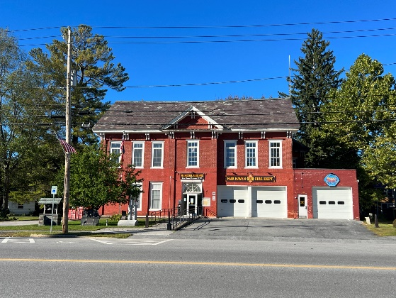
Town Office
The Fair Haven Town Office is located north of the Town Green. The Town Office is where government meetings are held and the location where the Fair Haven Police Department, Fair Haven Fire Department, and Fair Haven Historical Society operate.

Police Department
Figure 6: Fair Haven Town Office
The Fair Haven Police Department, under the leadership of Chief Bill Humphries, has become one of the best local police forces in the state. The department has four full-time officers and several part-time officers who provide full-time coverage. In-house detective service is also available. The Fair Haven Police Department often obtains grants from the state, like the Governor’s Highway Safety Grant, which offsets town expenses in detecting DUI infractions.

Fire Department
The Fair Haven Fire Department is a municipal, paid-on-call, all-hazards emergency response organization, responsible for fire suppression, vehicle extrication/rescue, hazardous materials mitigation, EMS support, and related emergency responses, in the Town of Fair Haven and our surrounding mutual aid area. Operational responsibility is vested in the Chief of Department, assisted by two Assistant Chiefs, a Captain, and one to two Lieutenants. Administratively, the Department President presides over meetings. As a municipal entity, the Department is funded via town taxes. A companion non-profit social organization, the Knight-Allen Hose Co, Inc., handles social events, fundraising, and supporting the Department with supplemental equipment purchase/donations as appropriate.

Authorized a membership of 30, the Department presently runs with around 18 members, many of whom are trained to the Firefighter II/Haz Mat Operations levels. Two members are also certified as Fire Training Instructors. The Department is one of nine Vermont fire departments that are dispatched via the Washington County NY Dept. of Public Safety in Fort Edward. FHFD is a member of mutual aid compacts with both Rutland County, VT and Washington County, NY. The Department typically runs around 100 calls for service per year.

Current Apparatus Inventory:
  - ETA 521 – 1997 International/E-One Pumper-Tanker; 1,250 GPM pump; 1,500 gal. tank. Note – scheduled for replacement in 2025
  - ER 522 – 2011 KME Rescue Engine; 1,500 GPM pump, 750 gal. tank; 30 gals. Foam; Amkus hydraulic rescue system
  - Brush 523 – 1995 Dodge Brush/Utility Truck; 250 GPM pump; 300 gal. tank; pump & roll

Emergency Management
Responsibility for the safety of Fair Haven’s residents and visitors rests with the Town Manager, in his/her capacity as Emergency Management Director. Typically, the Selectboard appoints an Emergency Management Coordinator (EMC) to oversee the Town’s activities in the four phases of Emergency Management – Preparedness, Response, Recovery, and Mitigation.
- Preparedness – One of the key functions of the Emergency Management Coordinator is the preparation and annual updating of the Town’s Local Emergency Management Plan (LEMP). This document serves as a brief but comprehensive overview of the Town’s Emergency Management system, including contact information for key personnel, information on shelter sites, delineation of responsibilities, and a National Incident Management System (NIMS) framework, to be used in the management of emergencies both large and small. Updated annually, the LEMP is a required document for maximum State funding matches under the Emergency Relief Assistance Funding (ERAF) Program.

- Response – “Response” activities address the short-term, direct effects of an incident, and seek to save lives, protect property, and meet basic human needs. In Fair Haven, response services include fire suppression and rescue through the Fair Haven Fire Department, emergency medical treatment and transport via the Fair Haven Rescue Squad, and law enforcement and security, provided by the Fair Haven Police Department and the Fair Haven Constables. In this phase, the EMC is in contact with Vermont Emergency Management’s Emergency Operations Center (EOC), if activated, and requests/coordinates the distribution of necessary state or federal assets via the Watch Officer or the EOC

- Recovery – “Recovery” is the process of rebuilding, restoring, and rehabilitating the community following an emergency. The Town would maintain records of expenses incurred in the recovery from disasters, including road and culvert repairs. This information is forwarded to the Vermont Division of Emergency Management and Homeland Security and the Vermont Agency of Transportation, where it can be used to support federal Disaster Declaration requests and can lead to the Town’s eligibility for significant cost reimbursements.

- Mitigation – “Mitigation” is taking action before a disaster occurs to reduce loss of life and property damage. A critical component of The Town’s mitigation strategy is manifested in the Local Hazard Mitigation Plan (LHMP). Compiled with the assistance of the Rutland Regional Planning Commission, and approved by both Vermont Emergency Management and FEMA, this document assesses the Town’s relative risk of impact from various natural and man-made disasters, and develops strategies and projects to help minimize these risks. Fair Haven’s LHMP is slated for revision/readoption in 2024. A FEMA-approved LHMP allows the Town to receive 12.5% state funding for eligible disaster-related recovery projects, instead of the standard 7.5% state match.

Solid Waste
Fair Haven belongs to the Solid Waste Alternatives Communities (SWAC), which includes 10 towns. In November 1989, nine towns, including Fair Haven left the Rutland County Solid Waste District and eventually formed SWAC, which is composed of representatives of each municipality, appointed by the Selectboard. Fair Haven has a transfer station and SWAC towns work cooperatively to manage hazardous and solid waste in a cost-effective and environmentally responsible manner.
On July 1, 2020, Vermont state law banned the disposal of food scraps in the trash or landfills. SWAC provides information on home compost options. Music Mountain Compost, Casella Resource Solutions, and Wyman Frasier Compost of Vermont serve residential and commercial composting needs in Fair Haven.

Schools, Library, and Childcare
There are two schools that are part of the Slate Valley Unified Union School District that are located within the town of Fair Haven:
Fair Haven Grade School serves students Pre-K through grade 6.
Fair Haven Union Middle and High School serves students in grades 7-12

The District Mission statement reads as follows: “We are dedicated to the academic excellence of every student by empowering them with the means for the successful completion of district, state, and national educational standards and by challenging them to be productive members of society. We are committed to a comprehensive system of support to assure each student has the opportunity to develop the skills and talents necessary for college and career readiness.”

Fair Haven’s two schools have a good relationship with the town and residents are often seen cheering at athletic games in good numbers. The music and drama productions have enjoyed sold-out performances of their Shows.

Fair Haven Grade School
The school sits on 7.31 acres of land. Many acres are in wetlands and while the school is high on the bluff the fields below are prone to some flooding, the good news is this affords opportunities for lessons in science and conservation.

Fair Haven Grade School was built in 1916. The school opened its doors at the beginning of the spring semester of the 1916-17 school year. Records found for the spring semester of 1917 indicate a student population in grades 1-8 of 310 students. An addition to the rear of the school was built during the 1973-74 school year to accommodate the influx of students from the parochial school that closed in the early 1970s. This addition included a new gym and library along with many new classrooms. A third addition was erected in 1989, and an energy upgrade was completed in 2007.

The student population is roughly 250 (Pre-k through grade 6).

The school has long enjoyed a good relationship with the community being in proximity to the center of town and having many of the townspeople attend school in that same building. During the year, the school sponsors events that include the community, including Applefest and a Celebration of Learning evening in the Spring. There are chorus and band concerts and programs which display the talents of the children and their development throughout the year.

The school maintains a comprehensive website and shares a monthly newsletter that disseminates information to students, faculty, and the community.
Education spending per equalized pupil:
FY2020 $16, 073.94
FY2021 $16, 393.74
FY2022 $16, 497.92
FY2023 $16, 957.13
FY2024 $18, 103.06

Fair Haven Union High School
Fair Haven Union Middle and High School is located at 33 Mechanic Street at the end of two dead-end streets and sits on 30.25 acres of land. The high school opened its doors on October 7, 1957. Three additions have been erected, the first in 1965 when the Library wing was added. In 1973-74 the industrial arts and the “open English” wing were added to alleviate overcrowding. The most recent addition was built in 1997 with a new second-floor science wing and a new music wing. Recent renovations have been completed to update mechanical, electrical, and plumbing systems as well as create additional classroom space.

The school educates students from six towns: Benson, Castleton, Fair Haven, Hubbardton, Orwell, and West Haven. The school’s 2023-2024 school year has about 530 students and offers a wide variety of course and learning opportunities including Advanced Placement and Dual Enrollment (college credit) classes, Family and Consumer Science, Fine Arts, Languages, Mathematics, Physical Education, Science, Social Studies, English, Music, Health, Work-Based Placement, and Technology Education (including Digital Arts). The school is also involved with the Stafford Technical Center in Rutland which historically hosts approximately 35 students in grades 11 and 12. The FHU Annex offers a flexible schedule to accommodate the learning needs of students, including work-study at local businesses. Approximately 20 students in the 2023-2024 school year participate in work-study.
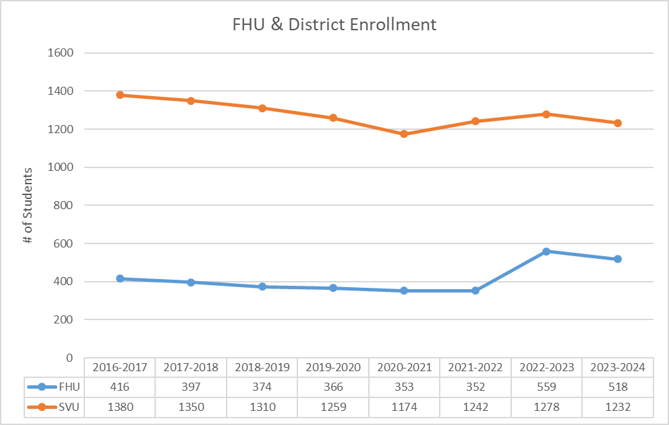
The constantly changing world of technology continues to be a focus of the administration of the school as the world is now a mouse click away; certain research that took hours can now take seconds. The task of keeping the technology and bridging the generational technology gap between students and parents has challenges but the school is committed to preparing students for the modern age.

Both the indoor and outdoor sports facilities are heavily used by students with the track being used by area residents when not in use by the school. Extracurricular activities include sports (Basketball, Baseball, Bowling, Cheerleading, Cross Country, Field Hockey, Golf, Football, Indoor Track, Soccer, Softball, Track & Field, and Wrestling) and clubs (Alpine, Art Club, Belonging, Be You, Book Club, Chess, Community Service, Future Farmers of America, GSA, No Place for Hate, First Lego League Robotics Club) and other activities (Band, Bass Fishing, Chorus, Drama, Homeward Success, Keynotes, Lacross, Marching Band, NHS, Student Government, Student Voice, Volleyball, and Yearbook).
Figure 7: Fair Haven Union High School Enrollment

Both schools are adapting to the evolving landscape of education, facing challenges that have significantly changed over generations. The diversity of students, including those without stable homes, poses additional strains on the local educational system.

The community has commendably supported the schools, not only financially. In recent years, the cost of educating our children on a statewide level has consistently risen, coinciding with a decline in school population. While the homestead tax rate has decreased over the years as a result of Act 4; the school merger, there remains a pressing need for state-level initiatives to devise a new, cost-effective approach to funding Vermont’s education system while ensuring that schools have adequate resources to support the success of all our students.

Childcare
Fair Haven has several small daycare facilities in town. There are additional childcare providers within a 10-mile radius, including in Benson, Castleton, Poultney, and West Haven.
Library
The Fair Haven Free Library is south of the Grade School. A library existed in Fair Haven as early as 1826, but it was not until 1904 when steel magnate Andrew Carnegie offered $8000 that the current structure was erected. The Fair Haven Free Library is home to a large collection and offers up-to-date digital service. The Friends of the Library host a myriad of community programs throughout the year.

Recreation Facilities
Our Village Green contributes as much to our town’s identity as anyone or anything in Fair Haven. Originally owned by Matthew Lyon, our most famous (and notorious) ancestor, it was granted to the town by Tilly Gilbert in 1805. With its large maples, marble post fence, park benches, shady walking paths, and a fountain in the middle, it is a beautiful centerpiece of our downtown. The green is rumored to be the only “spoked” town green left in Vermont, a layout where paths radiate outward from the fountain. Many people enter Vermont through Fair Haven every day and never see our lovely green. The Plan encourages the Town to find ways to draw people to our downtown and the Village Green, and all the events held on it, are a great opportunity to do so.
Besides our village green or just “The Park” as it is commonly known by our residents, there are five other areas in town which are or can be used for recreation of some kind:
- The Fair Haven Union High School fields, where football, soccer, track, baseball, and softball can all be played formally in games.
- The Fair Haven Grade School playgrounds and fields can be used for both formal and informal play. Anyone may play tennis on one of the courts if they are not already in use, and there are basketball hoops designed for pick-up games or individual practices.
- Marsh Pond Wildlife Management Area, south of Old Marsh Pond, is a 90-acre parcel managed by the Vermont Fish and Wildlife Department and people fish, hunt, hike, and view wildlife here. Access to the parcel from Pond Road is restricted sometimes.
- The “South School Playground” which is east of the Eagles’ Club on Academy Street. It is small but there is room for a softball or Little League baseball field and a playground for small children.
- The former airport grounds at the northerly end of Airport Road is ripe with potential. A “Fur Haven Dog Park”, home for a model airplane club, or adding walking paths may make sense.
The Plan encourages the Town to scope adding recreation facilities at the South School Playground and former airport grounds and to seek public input on where/what recreation facilities and paths should be built.
PUBLIC FACILITIES AND UTILITIES GOALS
- To plan for, finance, and provide an efficient system of public facilities and services to meet current and future needs.
- To support educational and vocational training opportunities sufficient to ensure the full realization of the abilities of Fair Haven’s residents.
- To encourage the availability of safe and affordable childcare.
- To maintain and enhance recreational opportunities for Fair Haven’s residents and visitors, and to preserve Fair Haven’s New England character.

PUBLIC FACILITIES AND UTILITIES ACTIONS
- Annually review the Fair Haven Local Emergency Management Plan and Local Hazard Mitigation Plan and revise these plans as needed.
- Collaboratively work with Fair Haven Schools, Stafford Technical Center, and surrounding towns to identify further opportunities for students to gain job training opportunities besides a four-year degree.
- Promote state agency information on the Town website and in the Town Hall on best practices for home use of public facilities and services, including proper disposal of cooking grease, water conservation, and recycling.
- Evaluate town-owned property’s current use and identify potential future uses to benefit the citizens and environment of Fair Haven most efficiently.
- Work with the Rutland Regional Planning Commission to identify and pursue funding opportunities to upgrade the wastewater facility, and other public facilities and services, as needed, to meet current and future needs.
- Annually evaluate the Consumer Confidence Report and take action as needed to maintain Fair Haven’s healthy water quality.
- Attend training by state, regional, local, and community organizations to grow knowledge in meeting day-to-day and long-term public facility and utility needs.
- Scope the feasibility of using Howard and Sheldon Reservoirs, or other waterbodies, as a potential emergency water source.
- Work at adding recreation facilities at the South School Playground and former airport grounds and seek public input on where/what recreation facilities and paths should be built.
- Address collection system needs. Some manholes need to be rehabbed and sewer lines replaced or lined. Specifically, Sewer Lines on Capital Hill, Prospect and Cedar were noted as poor condition during a 2022 Camera inspection and manholes at the beginning of West Street Prospect Street, and Cedar Street.
- Enlarge Adams St. Pumpstations to accommodate both pumps running simultaneously during high flow situations.
- Budget and plan sludge removal, given the trend in rising costs.
- Encourage residents to join the Fair Haven Fire Department
- Ensure Fair Haven Rescue Squad exists, given the distance from the Rutland Regional Ambulance service.
- Acquire equipment, as needed and as the budget allows, to meet current and future facilities and utilities needs.
- Continue participation in the regional Communications Union District to ensure meeting communication needs.
- Work with the Fire Department to plan growth in a manner in line with the Department’s capabilities.
- Seek non-residential property tax-based sources of funding to meet facilities and utilities needs and infrastructure improvements.
- Review the Town Reserve Funds to determine the baseline level of funding for each fund. Funds should be maintained on the identified based on an annual amount of growth to reach a specified amount or based on replenishment of an existing level already attained and only added to when a portion of the funds are drawn down for a specified purpose.
- Maintain all recreational facilities and the Town’s Recreation Department Program. Begin a search for a full-time Recreation Director.
- Plant maple saplings in the Park every decade to replace big maples as needed.
- Continue to support all cultural events that promote Fair Haven and the greater region.
- Cooperate and Support Fair Haven’s schools and relevant entities to continue developing a diverse college and career readiness to meet the needs of all students; to establish community engagement, service, and partnerships; to recruit, develop, retain, and leverage exemplary educators.

ECONOMIC DEVELOPMENT

Past and Present
The Park and Downtown remain the heart and pride of the community, serving as the heart of the business district. The area has a good mix of single and multi-story historic buildings and uses, including retail, office, restaurants, services, governmental, churches, library, residential (elderly, rental, and single-family), a second story opera house, a beautiful green space, and recreation. It is fully serviced by water, sewer, public transportation, a state designated park and ride, LED converted street lighting, free public Wi-Fi, and even an electric vehicle (EV) charging station. In addition, the local grade school, Police Department, and Fire Department are located in the area. In other words, the area serves as the epitome of a traditional Vermont downtown surrounding a well-cared for town green. Besides buildings surrounding the Park, the Park itself is on the National Register of Historic Places.

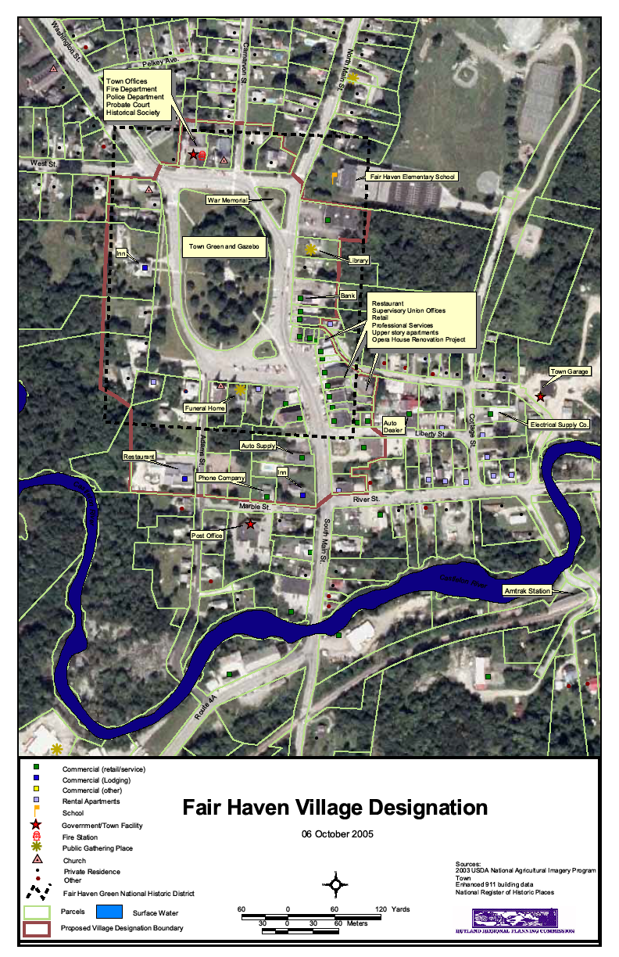
The broad land use pattern downtown is fairly well established, but there are opportunities for redevelopment, façade improvements, and rehabilitation. To support the downtown’s viability and livability, the Town participated in the state’s Downtown Program via a Village Center Designation. The designation allows Fair Haven to receive grants for improvements within the identified area, gave priority designation for some state-funded grants, and allowed property owners some eligibility to receive tax credits for building improvements. The Town intends to re-apply for at least a Village Center Designation, if not a Downtown Designation, so the area’s businesses, property owners, and the Town can once again benefit from the Downtown Program. The boundaries of the original designation are shown in the figure 8.
Figure 8: Boundaries of original downtown
Continuing at least the Village Center Designation will allow the Town to further the intent of the Future Land Use and other sections of the plan herein. It will better allow public and private physical improvements in this all-important mixed-use area of Town. The designation will allow focused resources to help this area have a better opportunity to thrive. Having access to historic tax credits will support redevelopment/rehabilitation of older and historic properties while preserving the historic character of the designated center. In addition, the Town could benefit from downtown transportation funds intended to improve pedestrian and other public safety. (Tax Increment Financing (TIF) would be beneficial to the town should the opportunity arise.)

Commercial and Industrial

Fair Haven has a population of only about two thousand eight hundred, but we are the primary commercial center for about the same number of people, i.e. the residents of West Haven, Benson, and Hampton, New York. We are also, if not a primary or at least a secondary commercial center for Castleton, Hubbardton, Orwell, Poultney, and Whitehall, New York.

Fair Haven has for a long time had a slate industry to employ some of our residents, but we need more than that. Few of the jobs could be classified as “careers”, but it was a good place for mostly young, mostly men to get started; many, after establishing themselves as good and cooperative workers, later applied for good jobs, outside town, especially at the General Electric plant in Rutland.

Present day industries include slate quarries and slate manufacturing. We are well suited to having industry with our advantages of transportation and our desire for local jobs, and we need to continue to encourage industry, and business to locate in Fair Haven.

As in many towns, business interests have expanded into outlying areas. In Fair Haven’s case, the greatest expansion happened North and West of the village center. Commercial businesses in the north of town include pharmacy, restaurants, grocery store, hardware store, banks, auto sales, truck stops, insurance agency, dog daycare, and fast food. Commercial businesses in the western side of town along the New York boarder include RV service and sales, storage facilities, and the Vermont Welcome Center. Other small home occupation businesses are scattered throughout town, while we still maintain an active business district in the center of town.

Fair Haven’s residents work in an array of industries as shown in Figure 9.

Figure 9: 2022 Industries Residents Work In – 2022 American Community Survey 5-Year Estimate

In 2021, 924 people worked in Fair Haven but lived in another town and 951 people lived in Town but worked somewhere else. The average commute for 2021 residents was 30 minutes meaning residents worked in places spanning Rutland VT, to Granville and Fort Ann NY.
Although many residents live and work in Town, with 407 people doing so in 2021.

ECONOMIC DEVELOPMENT GOAL
- Attract and retain business in our village center that will support our plans to make Fair Haven a destination center for visitors and residents.
- Incentivize and attract travelers, both nearby New Yorkers and other Vermonters to the town of Fair Haven, utilizing the Vermont Welcome Center.
- Promote, recruit, and maintain small businesses that will create jobs and increase our tax base in Fair Haven.
- Generate municipal revenue to help reduce the property tax burden on Fair Haven property owners.
- Have commercial businesses on the ground floor of all our large downtown buildings, with shops and offices on the upper floors. Apartments on the upper floors and in the back of commercial buildings on the first floor will help address downtown housing needs in the town.

ECONOMIC DEVELOPMENT ACTIONS
- Encourage town of Fair Haven and businesses to utilize the Vermont Welcome Center to promote the area businesses and events.
- Work with Rotary and the Lakes Region Chamber of Commerce to increase the number of businesses in Fair Haven. Attract new businesses and light industry to Fair Haven.
- Re-obtain the Town’s village Center Designation or, if possible, obtain a Downtown Designation, in an effort to revitalize and to attract business and visitors to the downtown area.
- Promote and develop community events at the Park and surrounding natural resources. Continue events like, Concerts In The Park, Spring Fling, Applefest, Lumberjack Show, Story Walk, and Chamber Car Show.
- Participate in activities and continue to support membership in Rutland Regional Planning Commission and CEDDR. Strengthen our relationship with these organizations with active members appointed to their boards,
- Create public/private partnerships that maintain, expand, and attract local business (e.g., apply for public infrastructure funding to help with fire code safety and pedestrian accessibility). Continue to utilize Tax Stabilization, Revolving Loans, and Building Better Communities grants. Help businesses apply for historic tax credits.
- Plan for and carry out infrastructure improvements as needed. This can be best accomplished with updating and annually maintaining a capital budget and maintaining reserve accounts.
- Improve the Town’s recreational programs so that people of all ages benefit, and, thus, helping to make Fair Haven even more desirable to live and work in. Explore the addition of a Recreation Director / Economic Development Coordinator position. Support our Volunteer Recreation Committee. Ensure staffing and budget for “Recreation Economy”. Investigate possibility of campsites at the Air Park.
- Examine the Zoning Ordinance and other regulations to ensure they are appropriately business-friendly, including for the recreation economy, green industry, IT/computer-based technology business, start-up and small business, adaptive re-use of existing buildings, and businesses that foster high level business growth.

HOUSING
Physical Housing Stock
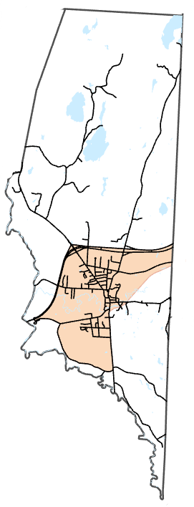
Fair Haven is a place where family life is emphasized, is known for beautiful Victorian-styled homes, and has 92 historic homes registered in the Vermont Register of Historic Places.
Fair Haven’s town center, or ‘Fair Haven CDP’ in the 2020 Decimal Census, and shown in Figure 10, holds 81% of Fair Haven’s population, 83% of all Fair Haven housing units, and 81% of all occupied housing units. This means much of Fair Haven’s housing and residents are within walking distance to the Green, Downtown, and the many goods, services, and attractions that residents need. Outside Fair Haven CDP, development density decreases quickly with agricultural and industrial uses more common.
Fair Haven’s housing stock is 71% single-family detached houses and 20% multi-family houses. Our housing has a variety of bedrooms, as shown by Figure 11. Most households in town own their home but 35% of households rent. The median year a home was built in Town was 1939. The Plan encourages home improvements in Town to improve the quality of the housing stock.
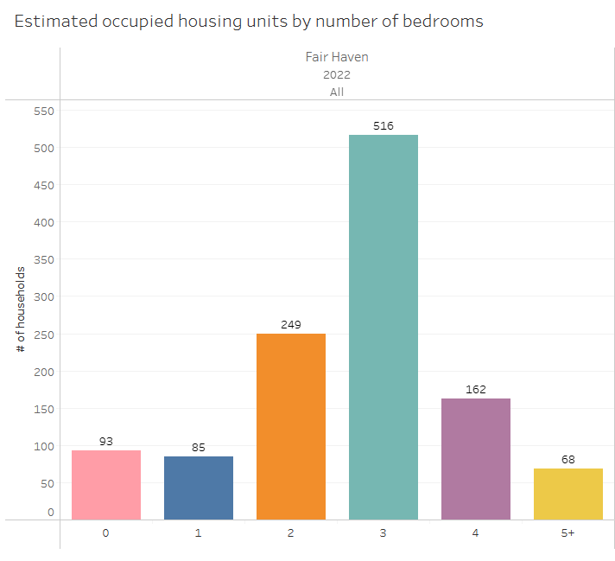
Figure 11: Homes by number of bedrooms, American Community Survey 5-Year Estimates

Figure 10: Fair Haven CDP
(in orange)

The town hosts 4 subsidized and affordable housing projects: Appletree Apartments, Alfred Court, the Adams House, and the Park View House. Mobile homes are found scattered around the Town but are mainly found in Haven Meadow MHP, which is owned by the Housing Trust of Rutland County.

Seasonal homes are a small part of Fair Haven’s housing stock with year-to-year census data estimates ranging between 0% to 8%. Short Term Rentals, from websites like Airbnb and Vrbo, are on the rise in Fair Haven, growing from 2 units in May 2015 to 28 units in May 2023, according to State of Vermont data acquired from AirDNA, a data analytics company.
Affordability
Affordable housing is commonly defined as spending 30% of income on housing expenses. Vermont Housing Finance Agency's Home Price Affordability Calculator estimates a home's affordable purchase price for the average Vermont buyer, assuming a 5% downpayment, average statewide interest rates, property taxes, insurance premiums, and closing costs. Using the 2022 median household income for Fair Haven at $65,850, this calculator estimates that the median Fair Haven household could afford a home priced at $180,500 if they had $17,922 available for closing costs.
In 2023, the median price of a home sold was just affordable for the median Fair Haven household, being priced at $179,000, a record high. Figure 12 shows Fair Haven has always had a lower median home sale price than Rutland County dating back to 1988. Anywhere from 20 to 30 homes are sold in Fair Haven each year.
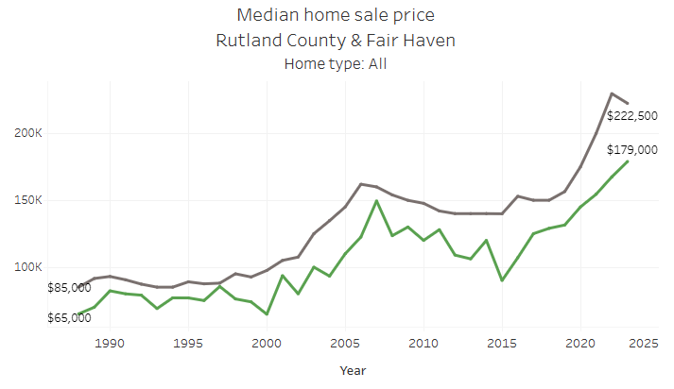
Figure 12: Median Home Sale Price for Rutland County, and Fair Haven from 1988 to 2023 – Vermont Department of Taxes

While the 2022 median household income for all households is $65,850, for renters it’s $37,813. 41% of renters have unaffordable housing, spending more than 30% of household income on housing costs and 13% of renters spend more than 50% of household income on housing costs.
There are several regulatory and financial factors on the local, state, and national levels that impact the cost of housing development and redevelopment, and the ability to provide housing:
- Fair Haven’s Zoning Regulations: The Planning Commission updated its zoning regulations to remove low-density suburban standards and allow more flexible property uses. This amendment encourages economic development, housing, and a walkable built environment. The zoning regulations were adopted on December 12, 2023.
- Act 47 (2023), known as the HOME ACT: In June 2023, Governor Scott signed a law that supersedes Fair Haven’s zoning regulations. Fair Haven has already worked with the RRPC during the zoning update to align with the state’s requirements including allowing duplexes wherever year-round single-unit dwellings are allowed, and five dwelling units per acre are allowed in areas served with municipal water and sewer. The HOME ACT, until July 1, 2026, also loosens Act 250 regulations for housing development. The act has funds available a Housing Resource Navigator program at the Rutland Regional Planning Commission, which is an opportunity in 2024 for the Town to receive an array of technical support to best serve the town’s housing needs.
- Vermont Housing Improvement Program (VHIP): State grants up to $50,000 per unit for property owners to repair vacant rental units, meet rental health codes, add additional units to existing buildings, or create accessory dwelling units (ADU) on owner-occupied properties. Participants must contribute a 20% match and those not creating an ADU must maintain Fair Market Rent prices. This program was further funded by the HOME ACT and promoted by Governor Scott.
- Inflation: Housing construction costs for a Vermont apartment building of mostly 1-bedroom apartments have increased 60% from 2020 to 2023 according to the Vermont Housing Finance Agency. This is attributed to the price of acquiring land, labor, and materials and having higher interest rates on financing.
Consistent with all chapters of the Plan, residential growth must not exceed the ability of the Town to provide facilities and services and must not have undue and adverse impacts on natural, scenic, cultural, and historic resources, areas, and features. Any expansion of water and sewer systems should be financed by the area that receives the ser.

HOUSING GOALS
- Ensure and support the availability of safe and affordable housing for all residents and the efficient use of land.
- Encourage a welcoming community where individuals and families from diverse backgrounds want to live in Fair Haven and are valued and respected.

HOUSING ACTIONS
- Collaborate with non-profit and private developers to ensure housing growth is safe and affordable, fits the character of the neighborhood, and meets the diverse needs of the community.
- Identify and promote desired housing types on specific sites to support new housing.
- Encourage Planned Unit Developments to conserve land and promote efficient land use.
- Support a mix of residential and commercial uses in the village area, a rate of residential growth compatible with Fair Haven’s small-town atmosphere.
- Encourage village Main Street property/business owners to rehabilitate upper floors over downtown businesses.
- Ensure the zoning map and zoning bylaws clearly identifies and incentivizes residential growth in line with the Land Use chapter.
- Work with existing entities like NeighborWorks, Efficiency Vermont, and BROC Community Action to help residents make home improvements and promote housing-related grants and low-interest loans on the town’s website and in town buildings.
- Where feasible and appropriate, acquire funds and designations that allow residents to lower home improvement costs.
- Plan residential development such that it coincides with facilities and utilities and allows for the adequate provision of services.
- Protect the architectural integrity of historic homes and structures.
- Preserve the rural nature of Fair Haven while offering all residents an attractive, affordable, and desirable place to live.
- Scope areas for potential use as a Planned Unit Development.
- Work with the RRPC to expand the grand list and residential growth in a manner that lowers residents’ tax burden and utility fees and does not unfairly impose a tax burden on existing residents.
- Pursue RRPC’s Housing Resource Navigator program for technical assistance in identifying future sites and housing types that fit the Village's character.
- Consider and seek public on pursuing a Municipal Planning Grant for a municipal housing needs assessment to better inform and target residential growth.

TRANSPORTATION
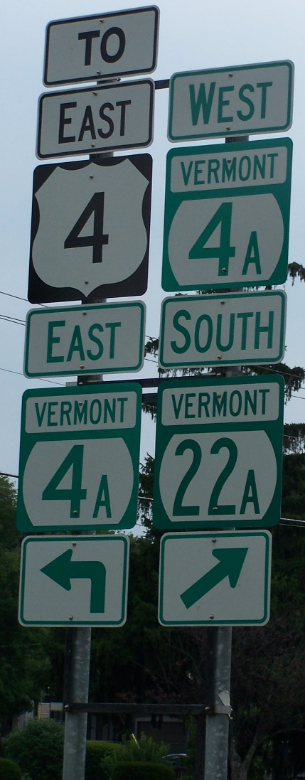
Fair Haven being along the Vermont-New York border and at the intersection of Route 22A and Route 4 makes it the “gateway” to Vermont from all points west and southwest. This prime location means efficient car travel time for residents and that many who drive by Fair Haven, including tourists from the tri-state, could take a quick detour to relax on the Green and enjoy our downtown.

At “Exit 2”, US Route 4 intersects with Vermont Route 22A. In Fair Haven, US Route 4 delivers a great deal of traffic to VT Route 22A North, which is the main corridor on the west side of the state to Burlington, Canada and northern Vermont.
Vermont State Law, 19 VSA § 302, defines town highways in four categories.
Class 1 Town Highways: an extension of a state highway routes and carry a state highway route number.
Class 2 Town Highways: the most important route in each town with the purpose of securing trunk lines of improved highways from town to town and to places which have more than a normal amount of traffic.
Class 3 Town Highways: minimum standards for Class 3 highways require that they be negotiable, under normal circumstances, all seasons of the year by a standard, manufactured, pleasure car. This includes, but is not limited to, sufficient surface and base, adequate drainage, and sufficient width capable to provide winter maintenance.
Class 4 Town Highways: are all other town highways including trails and pent roads. The Selectboard determines which highways are Class 4 highways.
Fair Haven transportation map shows that Fair Haven has a total of 38.1 miles of roads of which 27.56 miles are town highways of which 8.2 miles are Class 2 Town Roads and 14.9 miles are Class 3 Town Roads. There are 10.54 miles of state and federal highway, of which 10 miles is Route 22A and Route 4.
Figure 13: Route 4 and 22A Signs
A trolley ran from Rutland through Fair Haven to Poultney from 1903 to 1924 which supported Fair Haven’s hospitality business which thrived from 1800 to the 1950s.
Parking and Traffic Patterns
The adequacy and design of parking in and near the downtown district has been the source of much discussion, but generally, it functions well. The free parking lot downtown is easily accessible to customers of the businesses of our main commercial area and functions as a park and ride. Some residents and employees also use the large free parking area on the westerly side of Route 4A and Route 22A through the middle of town.
The Vermont Agency of Transportation has performed over 75 one-day automotive traffic counts in town dating back to the 1990s. The highest volumes were on Route 22A and Route 4, with lower volumes as you get further away from these roads and the center of the urban compact. The Town’s available traffic data as of the last couple of years is roughly historically average.
Bridges
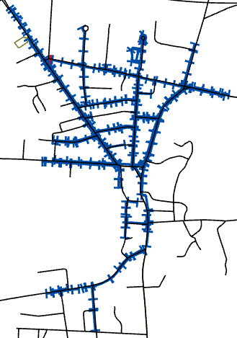
There are 2 bridges in Fair Haven of which 100% are over 20ft. The Vermont Agency of Transportation routinely inspects Fair Haven’s bridges and has online reports that rate the condition of bridge components and outline the bridge’s maintenance needs. The Plan encourages the Town to prioritize bridge maintenance needs by traffic volumes and to work with the state and other entities to reduce costs to the Town.
Sidewalks
Fair Haven’s sidewalk system is shown in Figure 14 and supports a dense mix of housing and businesses allowing anyone to get where they need to go on foot. The Plan encourages the Town to continue sidewalk maintenance to ensure a safe, economical, convenient, and energy-efficient transportation option and to consider expanding the sidewalk network to accommodate areas planned for growth.
Public Transportation
Figure 14: Sidewalks
We have four bus stops in town all run by the Marble Valley Regional Transit District: downtown on Main Street; on the corner of North Main Street and Capitol Hill; on South Main Street next to several industrial businesses; and one at the Shaw’s Shopping Complex. The Marble Valley Regional Transit District Bus Routes does connect with other regional networks allowing for the possibility of long-distance travel across Vermont via the Bus.
Culverts
Fair Haven has 345 culverts of which 41% are in excellent, good or fair condition. 55% of culverts’ condition is unknown and the Plan encourages the Rutland Regional Planning Commission to gather data on these culverts. 4% of culverts are in critical, poor, or urgent condition and the Plan encourages the Town to prioritize these or other culverts of similar condition for any future maintenance.
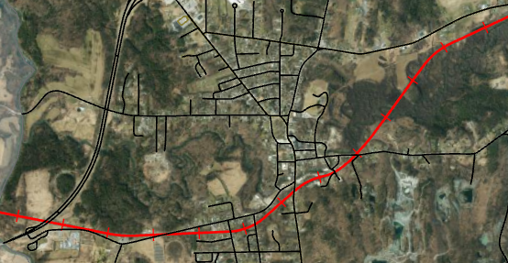
Railroad
The Clarendon & Pittsford Railroad, shown in Town on Figure 15, enters Vermont from Whitehall, New York near US Route 4 and runs easterly through Castleton to Rutland. Both freight and passenger rail service run through Fair Haven; there are 5 railroad crossings with none being in poor condition. An Amtrak train runs once a day on these tracks from New York City to Rutland (and vice versa). Fair Haven was for several years a stopping point for Amtrak, that stop was moved to Castleton several years ago. From 1838 to 1934, the Delaware & Hudson railroad line served Fair Haven.
Figure 15: Clarendon & Pittsford Railroad
TRANSPORTATION GOAL
- To provide safe, convenient, economical, and energy-efficient transportation systems that respect the integrity of the natural environment, including public transit options and paths for pedestrians and bicyclers.

TRANSPORTATION ACTIONS
- Prioritize all transportation actions according to the availability of funds for each individual project and work with the RRPC to identify funding opportunities to lower the cost of implementing, including sidewalk improvements.
- Work with RRPC and the state to identify necessary transportation improvements, including for the multi-modal transportation system, and annually monitor updates to state and regional transportation data, including state ratings of all bridges.
- Establish and improve pedestrian facilities, including sidewalks, in areas of greatest traffic and recreation value.
- Seek public input on ways to improve vehicular access to and parking near downtown businesses.
- Continue to grade and perform repairs to roads and ditches as needed.
- Seek public input on how to improve vehicular access to and parking near downtown.
- Utilize pavement preservation techniques to maintain and extend the life of pavement.

NATURAL, SCENIC, CULTURAL, AND HISTORIC RESOURCES
Fair Haven seeks to preserve its rare and irreplaceable natural, scenic, cultural, and historic areas, and features, and its working lands, including but not limited to the areas mentioned in this chapter. The Plan prohibits development that has undue and adverse impacts on these areas and features.
Conserved Lands
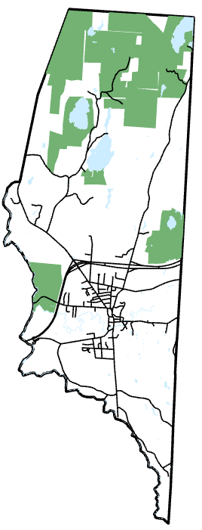
Figure 16 shows parcels that, as of 2021, are protected from development through public ownership, private ownership, or mechanisms such as conservation easements. The data is from the Vermont Protected Lands Database which is designed to facilitate conservation planning. These parcels are largely north of the urban compact, being owned by the Nature Conservancy or being a Town Forest, State Park, or Wildlife Management Area.
Figure 16: 2021 Vermont Protected Lands Database
Marsh Pond Wildlife Management Area, south of Old Marsh Pond, is a 90-acre parcel managed by the Vermont Fish and Wildlife Department. The Wildlife Management Area is composed of wetlands and a mix of vegetation and northern hardwoods, providing important habitat for waterfowl, amphibians, beavers, muskrats, and more. Access to the parcel from Pond Road is restricted. Recreation here includes fishing, hunting, hiking, and wildlife viewing.
The 131-acre Old Marsh Pond is a natural pond artificially controlled by the John Wood Dam and is a warmwater fishery for a half-dozen different types of fish.
Fair Haven has two town forests. One surrounds Inman Pond, the Town’s water source, ensuring the town has clean water for years to come. The second is the North Woods, between Bomoseen State Park and a parcel along the West Haven/Benson border, protecting an important wildlife corridor.
A small percentage of Bomoseen State Park, a 3,576-acre park, is in the Northeast corner of Fair Haven and includes Glen Lake. No Bomoseen State Park trails extend into Fair Haven, but we are a quick drive to a trailhead.


Wildlife and Vegetation
Figure 17: Coiled Rattlesnake photo taken by Sue Reed
We have most of the common Vermont animals, including black bear, eagle, and moose, but our most defining wildlife is the Eastern Timber Rattlesnake. The snake dens in the North Woods, one of two Vermont habitats for this rattlesnake, which is known for being timid and rarely out of its den.
The vegetation in Fair Haven varies from decorative and uniform, like the canopy of sugar maples on the Green, to diverse, like in the North Woods where a mix of sugar maple, red maple, several types of oak and hickory, ash, birch, beech, pine, and hemlock thrive. Fair Haven’s tree canopy is a valuable asset in providing shade and in protecting the town’s air quality.
Main Waterbodies and Wetlands
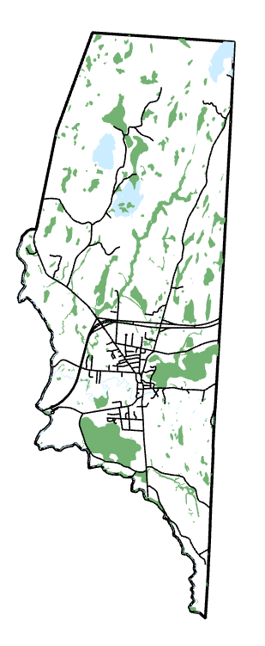
While there are other small water assets in town, the main three are Inman Pond (our municipal water supply), the Castleton River and the Poultney River. The Poultney River comprises our southern and western town boundaries and the state line with New York. U.S. Route 4 between Exits 1 and 2. “Mud brook” also runs into the Poultney River northwesterly of the village.
Figure 18: Fair Haven’s Wetlands – Vermont Agency of Natural Resources
The Castleton River has, since the start of the official town, been our historical source of industrial waterpower, and we are still hoping to have it generate an appreciable amount of electricity on the grid.

Wetlands are land areas with saturated soil for at least part of the year. They provide wildlife habitat, help manage water runoff, purify surface and groundwater, replenish aquifers, prevent erosion, and offer recreation opportunities.
Fair Haven’s wetlands, shown in Figure 18, are scattered across the Town with a large concentration of wetlands east and southwest of the urban compact. In 1986, the Vermont Wetlands Act was passed by the Vermont Legislature which tasked the Water Resources Board to identify wetlands that need buffer zones to protect wetland function. They established two types of Wetlands, with Fair Haven only having Class II Wetlands, which is a slightly less restrictive category.
Working Lands/Natural Resource Extraction
River-valley soils and possibly the best climate in the State of Vermont have traditionally made agriculture, particularly dairy farming, an important land use in Fair Haven. While other, smaller agricultural endeavors are still underway in Fair Haven, it will be hard in the future for the town to replace the land use, jobs, and scenery that dairy farming has always provided our town. The Plan supports local agriculture, and home gardening, especially where prime agricultural soils are.
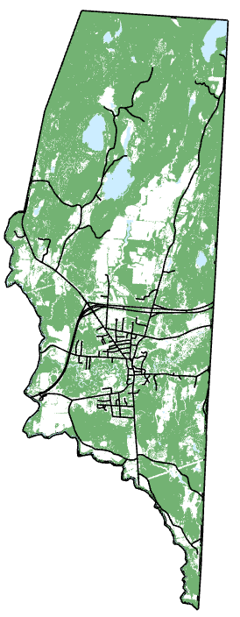
Fair Haven’s main geological asset is slate being at the end of a slate vein spanning from the Town to Pawlet VT, and Granville NY. The sand on top of the blue clay in the village was once a beach on an inland sea. Over millions of years blue clay became shale, and then ultimately slate. Our slate is tied to our economic well-being with residents employed in local quarries and mills. The Plan encourages the wise and efficient use of the Town’s geological resources, particularly slate. While much of Fair Haven’s blue clay was turned to shale and slate over millennia, in parts of town blue clay is still present in the substrate.
Fair Haven’s forests over the years, like much of Vermont’s, have been logged and replanted. The forested lands of today once were clearcut, generating logging revenue, and providing lands for cows to graze. Today, shown by Figure 19, Fair Haven is largely forested. The Town Forests from time-to-time are selectively logged. The Plan supports managing timber resources and updating forest management plans to protect Fair Haven’s forests.
Scenic Resources
Two major features dominate Fair Haven’s landscape: the Taconic Mountains and the Poultney River Valley. Much of Fair Haven’s rural character and appeal results from the scenic vistas that can be observed from many parts of the town and include an interplay of villages, mountains, forested hills, farms, fields, rivers, streams, ponds, and woodlands.
Figure 19: 2016 Tree Canopy - UVM Spatial Analysis Lab
Fair Haven’s scenic resources include but are not limited to Inman Pond, the Castleton River, State Forest Lands, Mud Brook, Old Marsh Pond, The Great Ledge (north of the village), Cedar Swamp, the Poultney River, North Woods (still untouched), Beaver Meadow and Carver’s Falls. Fair Haven is also fortunate to have many tree-lined streets in the village and along outlining roads. Trees provide shade, beauty, and habitat, can serve as food sources, and reduce noise and pollution, as well as increase property values by as much as 10%.
NATURAL, SCENIC, CULTURAL, AND HISTORIC RESOURCES GOALS
- To identify, protect, preserve, and showcase important natural, scenic, cultural, and historic features and areas of Fair Haven’s landscape.
- To maintain and improve the quality of air, water, wildlife, and forests.
- To support local agriculture, forestry, and related industries.
- To provide for the wise and efficient use of Fair Haven’s slate and geologic resources.

NATURAL, SCENIC, CULTURAL, AND HISTORIC RESOURCES ACTIONS
- Generate a Town open space, significant features, recreation/open space, and natural resources plan and work with the RRPC to acquire grants funds to lower the cost of creating and implementing the plan.
- Support work by relevant entities that protect the Eastern Timber Rattlesnake and the snake's habitat.
- Consider and seek public input on purchasing habitats and wetlands to protect and ensure no net loss of these important natural areas.
- Market local natural resource products, including agriculture and forestry.
- Oppose proposed development that adversely impacts the quantity and quality of Fair Haven’s natural, cultural, historic, and scenic resources, including but not limited to the resources outlined in the chapter.
- Promote best management practices on the Town’s website and in the Town Office, including lawn fertilizers, and pesticides, that protect Fair Haven’s resources.
- Inventory existing quarries in Fair Haven and collaborate with owners to identify the best use of these geologic, historic, and cultural resources for the town’s residents and the environment.

ENERGY
Fair Haven’s electrical infrastructure can be classified into four categories: electric generators, transmission lines, distribution lines, and service lines. Transmission lines transport electricity over long distances from electric generators to a town. Distribution lines then carry electricity to a neighborhood. Service lines deliver power directly to a home or business.
With two large truck stops and at least three other gas stations, Fair Haven residents have plenty of access to gasoline, Kerosene, diesel (fuel) oil and other petroleum products for motor vehicles. Propane is readily available in small containers from at least three retail businesses in town and in bulk from several companies outside of town but not far away. Electricity, provided to the townspeople by Green Mountain Power Company, is still primarily delivered in Fair Haven by pole lines.
Energy use in the town of Fair Haven parallels patterns throughout other rural communities. Transportation and home heating are the two primary draws on fuel and energy. Fair Haven in 2022 used 16,336,135 kWh of electricity of which 58% is from the residential sector and the remaining 42% is from the commercial and industrial sectors.
The 2023 Vermont Energy Burden Report found that Vermont households on average spend 11% of their income on energy costs – including electricity, transportation fuel, and home heating fuel. The report found that in Fair Haven, the median household has a moderate energy burden, spending 10.4% of its income on energy costs.
Efficiency Vermont and NeighborWorks of Western Vermont share rebate information, conduct energy assessments and offer low-interest energy financing and bill assistance. The Plan encourages energy conservation and energy-efficiency measures in municipal buildings, and by residents and businesses to help lower energy use and costs. From 2020 to 2022, 202 residential energy projects occurred in Fair Haven using Efficiency Vermont rebates or services. Figure 20 shows most Fair Haven residents use fuel oil or kerosene to heat their homes.
Figure 20: Households by Heating Fuel - 2022 American Community Survey
Hydroelectric
Fair Haven is blessed with an opportunity to produce hydroelectric power. According to a study done in 2014 and an existing FERC permit from before that the possibility exists to produce hydroelectric power either as a community endeavor or as a private business. The Upper Falls damn is an intact structure owned by the town and has preliminary if dated approval for such a project and a majority of the residents approved the project the last time it was asked. We see the river as a renewable resource waiting for the right circumstances to allow capturing that power as it did when the town was begun.

Wood
11% of Fair Haven residents burn wood to heat all or part of their homes, shown in Figure 18. The most efficient residents have a small wood lot nearby, and it costs them a little in gasoline and a lot of sweat to heat their homes. Lacking that, they can buy wood cut and split, they can purchase it in bulk (and work it up themselves), or use wood pellets, for use in stoves or furnaces.

Solar and Wind
Regarding both solar and wind power as with all energy projects in the town, the most important criteria to consider is input from the residents of Fair Haven.
The state has established a set of ambitious goals to increase renewable energy. Fair Haven supports those goals through solar and wind for both power and heating. The town and our plan see solar at its best on homeowners' roofs but also encourages projects that utilize under employed spaces. Places like abandoned parking lots, brownfields, and unused quarry locations are prime targets. Our plan supports the regional restrictions placed on large industrial wind power projects of a 100kw or more. Height restrictions would have to be considered as well. The town may not discourage smaller wind projects focused on local benefit. In the case of both wind and solar any project would have to show a viable decommissioning plan.

ENERGY GOAL:
- To make efficient use of energy, reduce emissions of greenhouse gases, and find a balance between the use of fossil fuels and renewable resources.

ENERGY ACTIONS:
- Determine suitable places and citing criteria for renewable energy generation resources.
- Continue the work by the Town of Fair Haven committee to explore and implement the use of our Upper Falls of the Poultney River for the generation of hydroelectric power for the Green Mountain Power Company grid.
- Where possible and financially feasible, make Town-owned buildings as energy efficient as possible, especially as existing buildings are rehabbed or updated.
- Work with landowners to ensure when new buildings are proposed, the design of such buildings should incorporate energy efficiency.
- Work with landowners, NeighborWorks of Western Vermont and BROC Community Action to provide information at the Town Hall and on the Town Website about funding opportunities to lower the cost of making homes and businesses more energy efficient.
- Seek public opinion on an Enhanced Energy Plan (EEP) that would allow the Town Plan to have substantial deference in the Section 248 regulatory proceeding. If the town decides to pursue this, work with the RRPC to ensure the EEP meets state requirements.
- Further provide transportation alternatives to single occupancy car transportation, including pedestrian and bike facilities, and public transportation.
- Support the installation of Electric Vehicle charging stations in Fair Haven.
- Support alternative energy sources that do not conflict with any restrictions in the Plan.
- Explore the feasibility of cooperative fuel-purchasing organizations and community energy-generating facilities to lower resident energy bills.

FLOOD RESILIENCE
As is so often stated within this Town Plan, Fair Haven is located in a particularly well-situated area. During times when areas around us are experiencing major damage from flooding, we have escaped with little or no damage. The 1913 flood, which had a major impact around us, only resulted in the loss of a shed at one of the slate mills in town. The 1927 flood which affected the entire state, had a much smaller impact on our town. Irene in 2011 devastated many towns and caused damage to one small area of Fair Haven, which was within the floodplain.
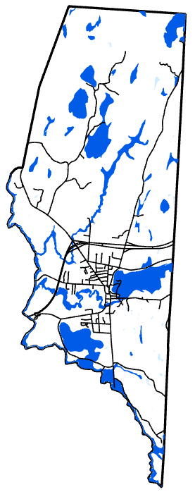
In Vermont, there are two types of flood impacts: water inundation and fluvial erosion. The National Flood Insurance Program (NFIP) covers water inundation, where water rises into low-lying land. For fluvial erosion, where a river overflows and cuts through, it’s covered by the Vermont Agency of Natural Resources River Corridor and Floodplain Management Program.
NFIP offers optional federally subsidized flood insurance to communities if they have land use regulations that meet federal standards in reducing flood damage risk. Residents’ insurance rates depend on Flood Insurance Rate Maps (FIRMs), which show flood-prone areas based on flood likelihood. Special Flood Hazard Areas (SFHA), shown in Figure 21, have a 1% chance of flooding in any given year, being the highest risk. Roughly 40 structures are in the Special Flood Hazard Area including a Green Mountain Power substation, the Town Garage, and a municipal wastewater pump station. 4 structures have flood insurance, with FEMA data as of 2019 showing that there have been no repetitive loss of property.
Vermont’s River Corridor and Floodplain Management Program supplement NFIP. A river corridor is not static, with steep terrain, frequent storms, development in the river corridor, and stream channel engineering influencing the degree of erosion.
"River corridor" means the land area adjacent to a river that is required to accommodate the dimensions, slope, planform, and buffer of the naturally stable channel and that is necessary for the natural maintenance or natural restoration of a dynamic equilibrium condition.
Figure 21: Special Flood Hazard Area - Federal Emergency Management Agency
- § 1422, 24 V.S.A. § 430
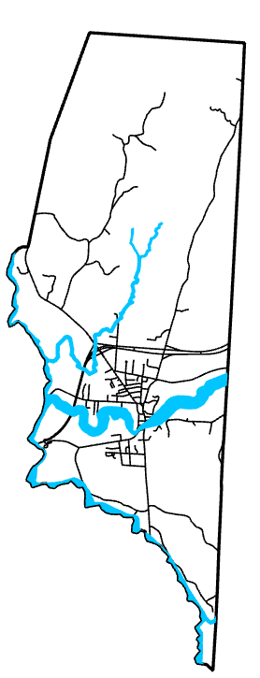
Fair Haven’s river corridors are shown on Figure 22.
Land use decisions impact flood resiliency. Overdevelopment in the river corridor can result in channel instability and infrastructural improvements can mitigate flood risk. The Plan encourages the town to acquire grant funds to improve infrastructure resilience, especially in the Village District and the Special Flood Hazard Area.
The Town’s most recent federally approved Local Hazard Mitigation Plan (LHMP) was adopted on February 8, 2021, and outlined heavy rain events and snowstorms, and their associated impacts, as being the “highest risk hazards” in Fair Haven. Both types of flooding mentioned above are deemed to have a >75% probability in a year with potential impacts being isolated occurrences of minor or moderate damage that could result in potential injury.
LHMP outlines Fair Haven’s flood history, showing there was $73,373 in local damage from Tropical Storm Irene in 2011. LHMP also provides a flood vulnerability summary, shown in Figure 23.
The Town, on Pages 15-19 of LHMP, has identified potential flood mitigation actions, evaluated and prioritized these actions, and assigned a Lead Party, Potential Funding, and time frame. The Plan encourages the Town to continue to follow LHMP’s hazard mitigation strategy, including goals and actions.
Figure 22: Fair Haven River Corridors - Vermont Agency of Natural Resources
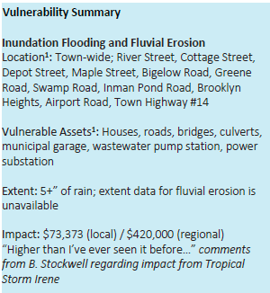
The Emergency Relief and Assistance Fund (ERAF) provides state funding to match Federal Public Assistance after federally declared disasters. Eligible public costs are generally reimbursed by FEMA at 75% with the state matching 7.5%. But communities can receive 12.5% if they have 4 mitigation measures or 17.5% if they participate in FEMA’s Community Rating System or adopt bylaws, that meet or exceed Vermont Agency of Natural Resources model regulation.
The Town adopting an LHMP resulted in the town getting to the 12.5% standard. Fair Haven considered the Vermont Agency model regulations years ago but the river corridor bylaw portion was not supported locally.
Figure 23: Fair Haven's Flood Vulnerability - 2019 Fair Haven Local Hazard Mitigation Plan
Wetlands are land areas with saturated soil for at least part of the year and they provide wildlife habitat, help manage water runoff, and prevent erosion. The Plan encourages the town to preserve its wetlands for flood resilience purposes.

FLOOD RESILIENCE GOAL
- To support flood resiliency and ensure the Town of Fair Haven can recover from flood events quickly.

FLOOD RESILIENCE ACTIONS
- Update Flood Hazard Regulations, as needed, to meet the most up-to-date State and Federal checklists.
- Invite the State to ground truth the town’s river corridor maps.
- Seek public input on River Corridor Protection language and if supported by the Selectboard, work with the RRPC to add this in the Town’s Flood Hazard Regulations.
- Pursue infrastructure improvements where appropriate, and related funding opportunities, to improve Fair Haven’s flood resiliency.
- Educate residents about relevant flood resiliency initiatives in Fair Haven.

LAND USE
Fair Haven is 71.5 square miles of which about 8% is the residential and commercial village, 43% is rural and open lands, and 49% is forests, rocky hills, wetlands, and Town/State-owned lands. Topographically, Fair Haven is at a lower elevation than surrounding towns, with local rumors that the origin of “Fair” in Fair Haven is due to this topography providing the best or “fairest” climate in the State of Vermont. The town’s highest point is 947 feet above sea level at the summit of “Coon’s Den” within the untouched North Woods. The residential and commercial districts are generally flat and lie roughly 385 feet above sea level.
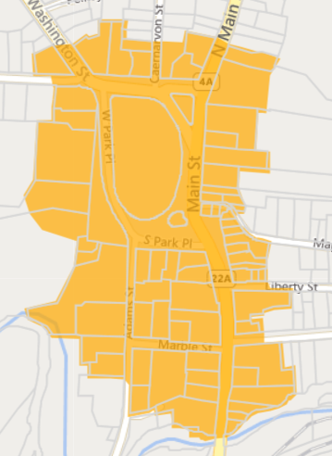
Figure 24: Village Center Designation - Vermont Planning Atlas
Fair Haven has a Village Center Designation, shown in Figure 24. The Village Center designation offers five benefits for local businesses to provide more welcoming storefronts and have greater accessibility: The 10% State Historic Rehabilitation Tax Credit, 25% Façade Improvement Tax Credit, 50% Code Improvement Tax Credit, and the 50% Technology Tax Credit. Also, the village qualifies as an existing settlement under criterion 9(L) of Act 250, relaxing regulations for future business development. The town may create a Special Assessment District within the Village Center, which can raise funds for capital expenses to support business projects. The village center also allows the town to have top priority for all state agency funding programs, many of which could further economic development. The Town intends to renew the Village Center designation as it supports the Plan’s economic development, land use, housing, and transportation goals that all promote smart growth principles.

The Land Use chapter is based on the Town's objectives for future development as they relate to and are influenced by natural and socio-economic factors; The goals and actions outlined in previous chapters have been considered. This chapter divides the Town into land use districts, outlining current land use and recommended future land use types and intensity. The Vermont Planning and Development Act authorizes towns to implement land use regulations such as zoning bylaws, provided regulations conform with State planning goals (24 V.S.A. §4411a).

Fair Haven is divided into nine Future Land Use Districts: Downtown; Residential; River Mixed Use; Commercial; Industrial; Rural; Recreation; Watershed; Flood Hazard Area. Each district’s boundaries can be located on the Future Land Use Map.
Fair Haven’s Highest Priority Interior Forest and Connectivity Blocks are located in the Rural, Floodplain, Commercial (northern part), and Watershed Districts. These areas are important as forest blocks and habitat connectors and the Plan and Future Land Use Map aligns with Act 171 guidance to minimize forest fragmentation and promote the health, viability, and ecological function of forests.

Downtown
The purpose of the Downtown Land Use District is to promote the renovation and re-use of historic structures in Downtown Fair Haven and to promote the construction of buildings in keeping with the existing built environment and The Fair Haven Green. Regulations for this district are intended to promote commercial and residential activity and maintain the area as the center of activity for the town. Regulations shall allow for creative uses of upper stories for residential, commercial, or entertainment purposes.
Residential
The purpose of the Residential Land Use District to promote single- and multi-family residential neighborhoods within a short distance of Fair Haven Village and to allow for uses incidental to or harmonious with the area's character. No commercial or industrial use shall be established within the residential district except for permitted home occupations.
Mixed River
The purpose of the Mixed River Land Use District to promote a mix of residential and commercial use of land and buildings immediately adjacent to the Downtown District. Mixed-use structures are encouraged to provide for both small-scale commercial and upper-story dwelling units.
Commercial
The purpose of the Commercial Land Use District is to promote commercial activity in the form of retail stores, restaurants, professional and business offices, light industry, and other establishments as detailed in the latest amended/adopted Zoning Bylaws. Development should maintain the character of the neighborhood and should promote ease of access between neighboring parcels and uses for vehicles and pedestrians. In the small segment of the district where the Highest Priority Interior Forest and Connectivity Blocks are located, future development should be designed to minimize forest fragmentation and promote the health, viability, and ecological function of forests.
Industrial
The purpose of the Industrial Land Use District is to allow for light and heavy industry, such as slate or stone works, machine shops, textile manufacture, laundry and dry-cleaning plants, or similar operations as described latest amended/adopted Zoning Bylaws. These areas are and shall always be separated from residential and natural areas to minimize use conflicts.
Rural
The purpose of the Rural Land Use District is to maintain a balance between ongoing agricultural practices, slate quarrying, low-density residential settlement, commercial use, and light industrial uses in the town. Any residential development in this district should consider the effects of permitted quarries in the area and should be designed to minimize forest fragmentation and promote the health, viability, and ecological function of forests.
Recreation
The purpose of the Recreation Land Use District is to ensure and provide public recreation areas. The following six areas within the town borders are set aside as public recreational areas: (a) A small area of airport property used as a barbecue picnic recreation area (b) Louis Faryniarz Playground - the area east of the Grade School known as the “playground” (c) The area at Fair Haven Union High School (d) The area at the former “South School” on Academy Street (e) The area of the Fair Haven Green known as the Park (f) The “Fur Haven Dog Park” north of the barbecue picnic recreation area
Watershed
The purpose of the Watershed Land Use District is the long-term protection of the Town's water supply. No development or any change in land use shall contaminate or potentially contaminate the Town’s water supply (Inman Pond) nor fragment any wildlife corridor.
Floodplain
The purpose of the Floodplain Land Use District is to maintain the flood water carrying capacity of all flood-prone areas in the Town and to ensure that any structures or uses permitted within these areas are properly protected from flood hazards and minimize forest fragmentation and promote the health, viability, and ecological function of forests.

LAND USE GOAL
- To plan development to maintain the historic settlement pattern of compact villages separated by rural countryside.

LAND USE ACTIONS
- Implement current zoning regulations to promote orderly development.
- Support or oppose development proposals based on meeting the land uses’ purpose as defined in the Town’s zoning and the Town’s land use goal.
- Work with prospective developers to adapt site plans to better conform with the Town’s opinion, including minimizing forest and wildlife corridor fragmentation.
- Re-obtain Village Center Designation or, if possible, obtain a Downtown Designation.
- Encourage the rehabilitation of Main Street properties by promoting available financial resources that help offset the cost of doing so.
- Participate actively in the formulation and implementation of the RRPC Regional Plan to ensure the regional functions of the area’s municipalities are represented.

IMPLEMENTATION & AJACENT MUNICIPALITIES
Implementation
The Vermont Planning and Development Act enables a municipality to guide its future growth through the preparation, continued maintenance, and implementation of a Municipal Plan (24 V.S.A. §4381). The Fair Haven Planning Commission, whose members are appointed by the Selectboard, is responsible for the preparation of the Fair Haven Town Plan. Since Fair Haven first adopted a Town Plan, it has been amended and re-adopted several times to reflect change in the Town, new legislation, and shifting resident attitudes.
Adoption of the Plan represents acceptance of its goals for guiding Fair Haven’s development. To realize full local control, implementation of the Plan takes two primary forms: enforcing zoning bylaws and through annual budgets.

The Planning and Development Act requires that Zoning Bylaws, as well as other bylaws, serve to implement the Plan and shall be in accord with its policies (24 V.S.A. §4410). Therefore, the Zoning Bylaws shall be in accordance with the Plan. On December 12, 2023, the Town adopted a series of Zoning Bylaw Amendments. The purpose of the amendment was to remove low-density suburban standards and allow more flexible property uses. This amendment encourages economic development, housing, and a walkable built environment.
The expenditure of public funds will be required to implement some of the recommendations contained in the Plan. In this regard, the Town adopts an annual budget for the fiscal year. Annual budgets outline expected costs and proposed methods of financing. Likewise, a capital program is a plan of capital projects to be undertaken, including estimated costs and methods of financing. Both tools may be used in promoting sound fiscal Town management.
Adjacent Municipalities in Vermont
The Vermont towns of Benson, Castleton, Poultney, and West Haven abut Fair Haven. These towns have similar development trends to Fair Haven, with compact settlements surrounded by rural countrysides, with the exception of West Haven, which is an agriculturally based town.
Through Vermont’s public notice requirements (24 V.S.A. §4384e), Fair Haven exchanges draft copies of the Town Plan with all these municipalities to ensure the draft and published plans are reasonably compatible with one another. Plan review also allows possible conflicts in land use to be identified and properly addressed. Fair Haven is involved in regional cooperation with these towns in several ways: coordinating E-911 addresses where neighborhoods cross town lines, active participation in the Rutland Regional Planning Commission (RRPC) and working with the Marble Valley Regional Transit Company. Fair Haven reviews RRPC’s Regional Plan to ensure it and the Plan are compatible. The Plan is in accordance with 24 VSA 117 § 4384, § 4385, and § 4386 which govern the preparation of the plan, hearings by the planning commission and selectboard, and adoption and readoption of plans by the Selectboard.
